**BANK LOAN REPORT**

**Purpose –**

The purpose of creating a bank loan report is to support informed decision-making, manage risks, and enhance the overall efficiency of the lending process. It helps banks evaluate the creditworthiness of borrowers, predict default probabilities, and assess risks associated with lending. Banks can make informed decisions about approving or denying loan applications based on the reports.

**Data source –**

This dataset is collected from Kaggle, and it contains 24 columns -

Loan ID, Loan Type (e.g., mortgage, personal, business), Loan Amount, Interest Rate, Loan Tenure, Loan Purpose, etc

[**https://www.kaggle.com/datasets/krishna54480/financial-loan**](https://www.kaggle.com/datasets/krishna54480/financial-loan)

**Page 1 (Summary) –**

This dashboard summarizes the bank's loan performance with key metrics and insights. It shows 38.6K total loan applications, $435.8M funded, and $473.1M received, with an average interest rate of 12.0%. Good loans account for 86.2% ($370.2M funded), while bad loans make up 13.8% ($65.5M funded). A loan status breakdown highlights fully paid, charged-off, and current loans, with detailed metrics for each. Filters for state, grade, and purpose enable further analysis, providing a clear overview to support decision-making.

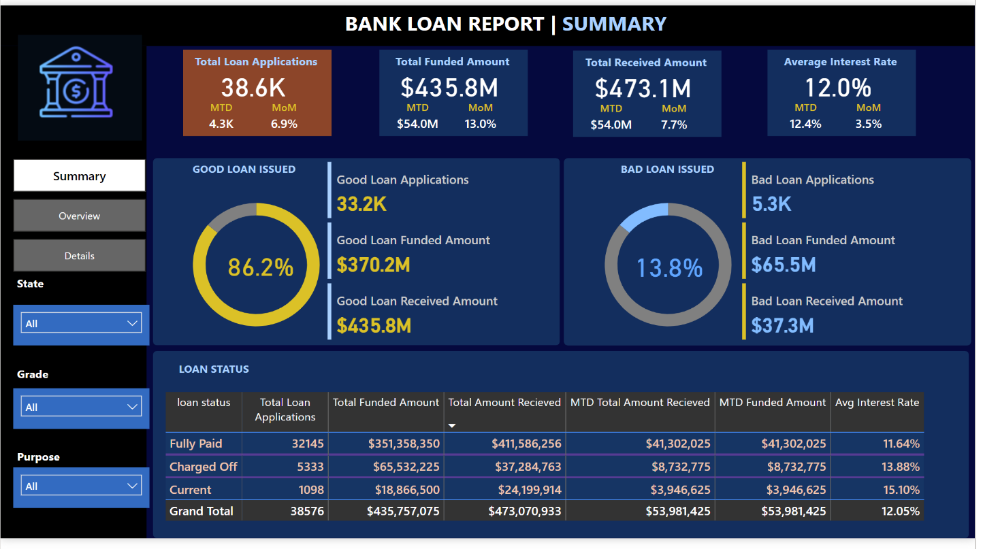

**Page 2 (overview) –**

This dashboard provides an overview of loan performance with key metrics such as total loan applications (38.6K), total funded amount ($435.8M), and total received amount ($473.1M) with a 12.0% average interest rate. It includes monthly trends for amounts funded, received, and applications, a geographic breakdown of received amounts by state, and a segmentation of loans by term (36 or 60 months). Additional charts show loan performance by employee length, purpose (e.g., debt consolidation or credit cards), and homeownership type (mortgage or rent). Filters allow users to analyze data by measure, state, grade, and loan quality.

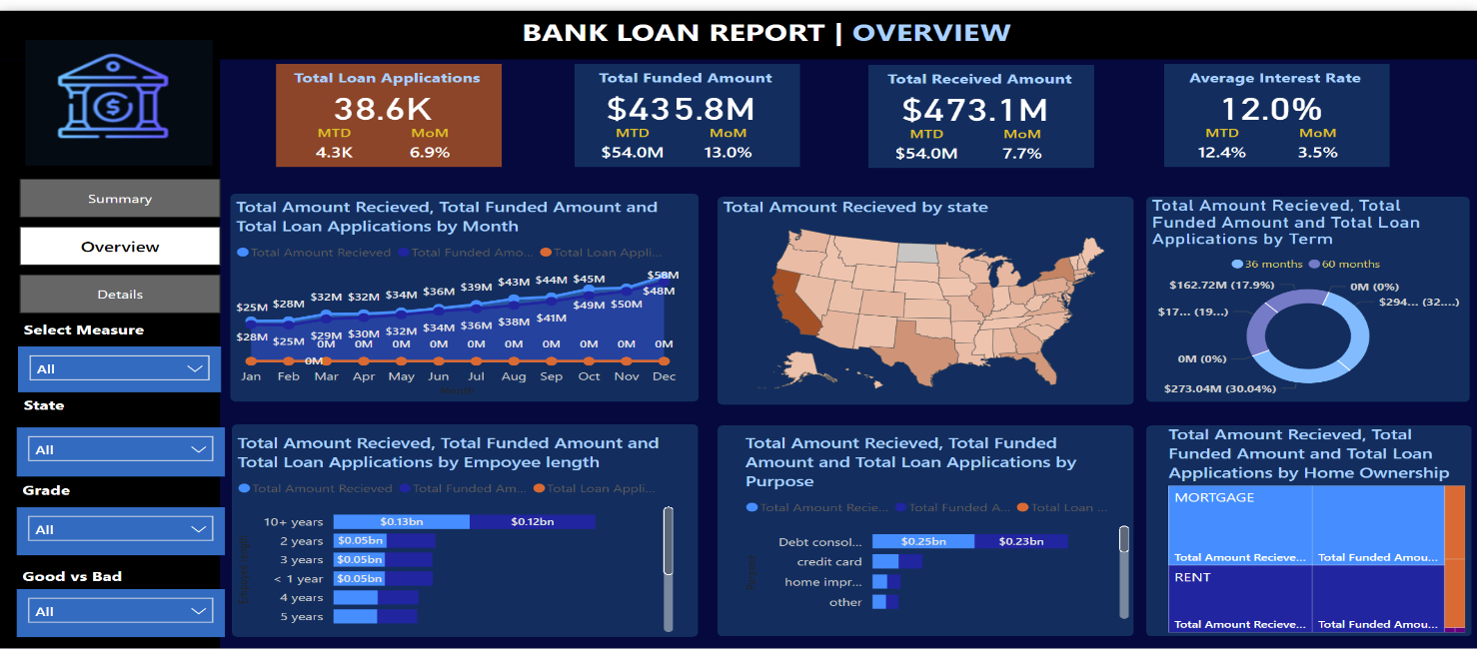

**Page 3(Details) –**

This dashboard provides an overview of bank loan metrics. It shows a total of 38.6K loan applications, with a total funded amount of $435.8M, and a total received amount of $473.1M. The average interest rate for these loans is 12.0%.

The detailed table below breaks down individual loan records by various factors such as ID, purpose, home ownership, loan grade, interest rate, and more. This allows for a deeper analysis of loan data, helping you understand trends and patterns.

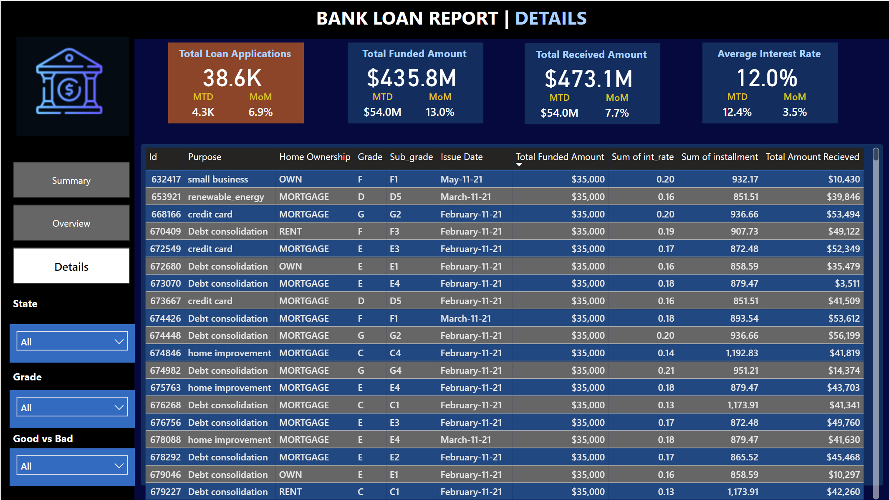

On the left side, there's a navigation and filtering section that lets you customize the data view based on Specific criteria. This makes it easier to focus on particular loan segments or attributes.